**Nonstop**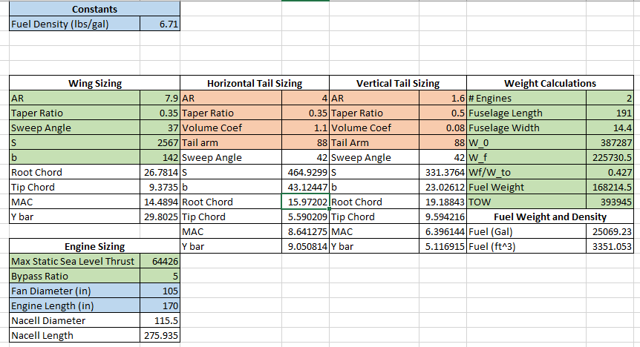

Wing, Tail, and Engine Sizing

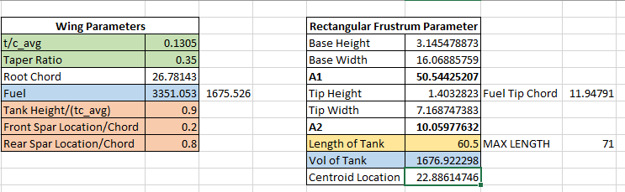

Fuel Tank Sizing

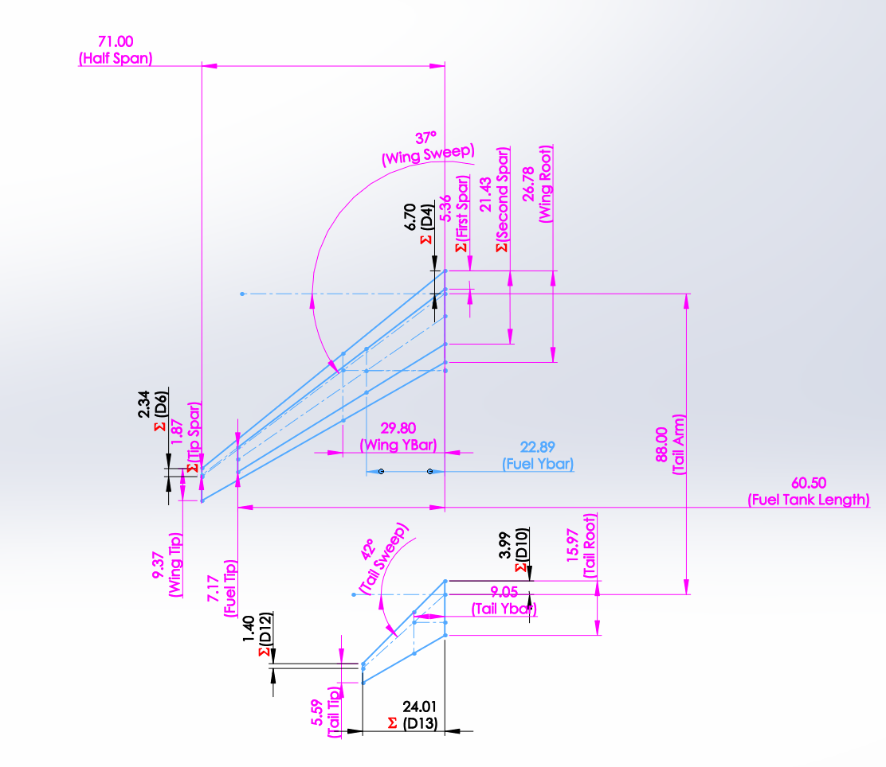

Nonstop Wing Layout Drawing

**Onestop**

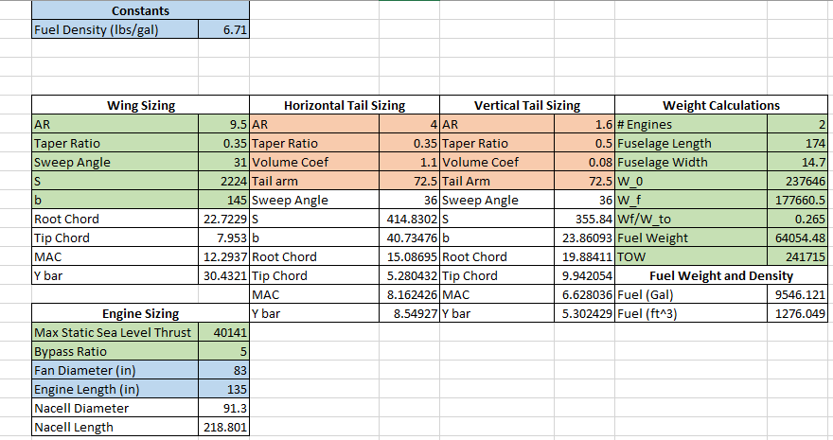

Wing, Tail, and Engine Sizing

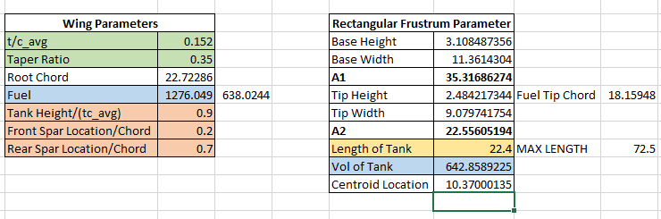

Fuel Tank Sizing

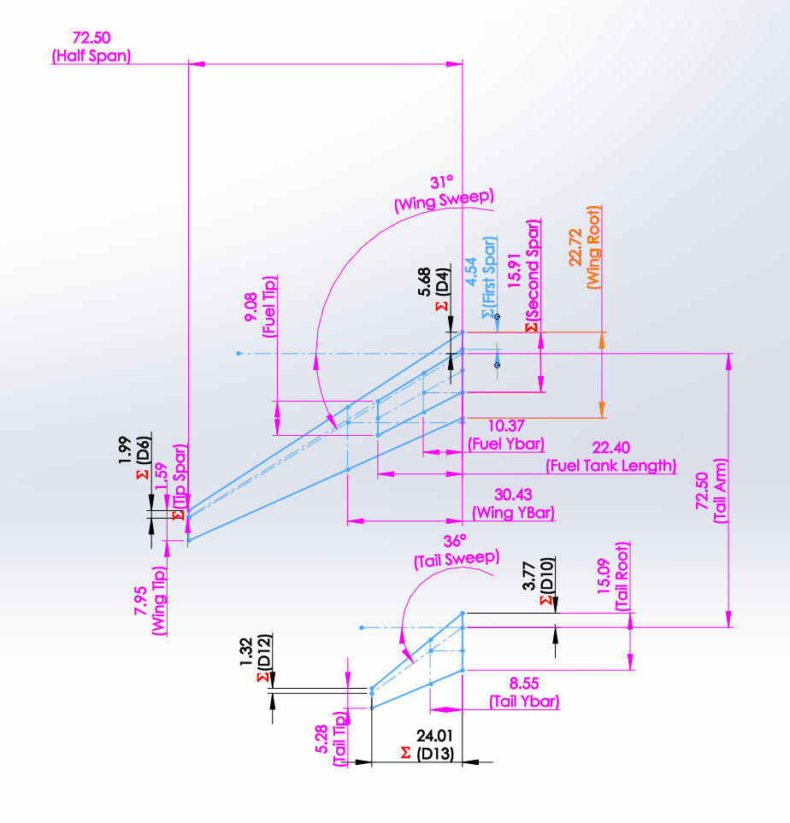

Onestop Wing Layout Drawing